2018 IEEE International Conference on Artificial Intelligence and Virtual Reality (AIVR)

HoloLearn: Learning through Mixed Reality for People with Cognitive Disability

Franca Garzotto§, Emanuele Torelli§ , Francesco Vona§ , and Beatrice Aruanno#

§ *i3lab - Department of Electronics, Information, and Bioengineering*

# *Department of Mechanical Engineering*

Politecnico di Milano Milano, Italy

franca.garzotto@polimi.it; emanuele1.torelli@mail.polimi.it; francesco.vona@mail.polimi.it; [beatrice.aruanno@polimi.it](mailto:beatrice.aruanno@polimi.it)

***Abstract -* HoloLearn is a Mixed Reality (MR) application that exploits Microsoft HoloLens to help people with Cognitive Disability improve autonomy in everyday life. Using HoloLearn, the user is immersed in a MR environment based on the surrounding space, in which s/he can learn simple daily tasks in an engaging way, with the help of a virtual assistant if needed.**

***Keywords - Augmented Reality; Mixed Reality; HoloLens; Holograms; Cognitive Disability; Virtual Assistant.***

1. INTRODUCTION

HoloLearn is an application for Microsoft HoloLens that addresses people with Cognitive Disability. Cognitive Disability (CD) is a broad concept encompassing intellectual or cognitive deficits derived from specific neurodevelopmental disorders (e.g., Autism), problems emerging later in life such as brain injuries, or neurodegenerative diseases like dementia. Most individuals with CD often experience co-occurring difficulties in different areas such as language and speech, memory, social behavior and motor skills [1], which affect their autonomy in daily life.

The goal of our research is to investigate the potential of wearable Mixed Reality (MR) applications to offer new forms of treatments for people with CD. Virtual Reality has been progressively acknowledged as a potentially valid support in therapeutic and educational treatments for people with CD. Some projects already exist, for instance, which explore therapeutic approaches based on social stories [5] and storytelling [4], mostly targeting young people with Autism [3][6]. The benefits of MR in the CD arena are much less explored. To our knowledge, the only HoloLens application that addresses people with Cognitive Disability is the one reported in [2], which addresses people with Alzheimer's Disease. The application consists of a set of tasks aimed at slowing down mental decline by strengthening short-term memory and spatial memory (which are usually damaged by Alzheimer's Disease).

Designed in cooperation with CD specialists (psychologists and therapists), HoloLearn aims to help people with CD to improve their autonomy in everyday life by learning some basic tasks typical of domestic routines.

1. THE USER EXPERIENCE WITH HOLOLEARN

The current version of HoloLearn supports two activities, called *Lay the Table* and *Garbage Collection*. These activities involve user’s movements in the physical space and the actions of dragging and dropping objects around. For an effective experience, the physical space in which the MR activities are performed should contain the elements functional to the designed tasks; for example, in the *Lay the Table* activity the user should be located near a real table, so that s/he can move around it. The view of the physical world is then enhanced with holographic content which represents the elements with which the user has to interact. Thanks to the

978-1-5386-9269-1/18/$31.00 ©2018 IEEE DOI 10.1109/AIVR.2018.00042

189

spatial mapping feature of HoloLens, the device is able to recognize the surrounding environment and put the holograms in the right place (for instance, in *Lay the Table* activity the objects are generated onto the real table).

HoloLearn interaction modalities are the standard ones supported by HoloLens. By changing the *gaze* direction (calculated from head orientation and movement tracking) the user updates her/his view of the MR environment. *Hand gestures* enable the interaction with holograms or other digital contents. *Air-tap* gesture selects and activates the gazed interactive element. *Tap and hold* (a “prolonged” air-tap) enables “drag&drop”: after the initial “instantaneous” air-tap on the gazed element, thumb and index must be kept closed to move the selected item to the desired position and must then be opened to release the element there.

1. *Lay the Table*

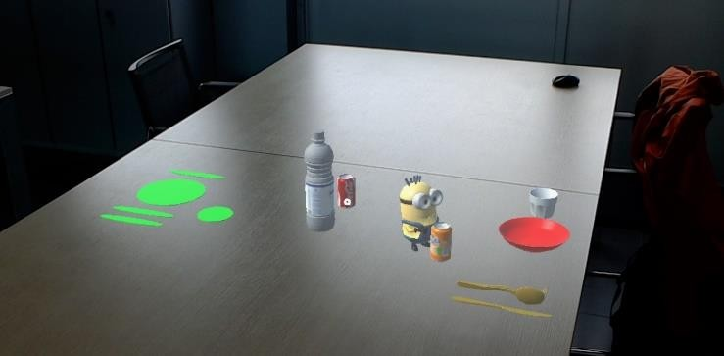

Figure 1: Lay the Table activity

The purpose is to teach the user to lay a real table using virtual objects (e.g. glasses, plates, cutlery, or bottles), putting them in the proper position. The MR environment consists of the physical space surrounding the user (including a table the dimensions of which must be at least one meter per side, to guarantee enough space for the holograms) and the holographic elements: the virtual objects appear on one edge of the table and some highlighted areas on the other ones [Figure 1]. To complete the task, the user must “drag&drop” all the objects to the correct positions, corresponding to the highlighted areas.

1. *Garbage Collection*

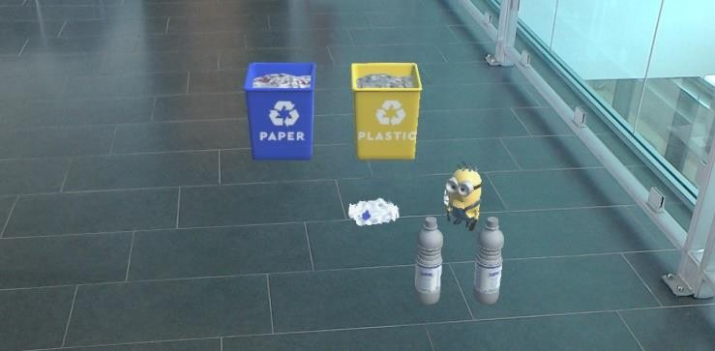

Figure 2: Garbage Collection activity

The purpose is to help the user to learn how to perform garbage collection properly, identifying the various types of wastes such as plastic, paper and glass. The MR environment consists of the room where the user is located, different holographic bins (for paper, glass and plastic) are placed on the floor, and some holographic pieces of trash located nearby. The goal of the activity is to move each holographic trash object inside the correct bin, again exploiting the interaction modalities supported by HoloLens [Figure 2].

1. *Virtual Assistant*

In order to improve the user’s attention during the assigned tasks, HoloLearn includes a virtual character that provides step-by-step visual tooltips to the user to support her/him and promotes engagement and fun through movements, gestures and sound. According to the therapists, the virtual assistant should be a character familiar to the users. We considered different options and showed them to some people with CD; finally, we opted for a Minion, a movie character well- recognized and liked, especially by young people.

1. IMPLEMENTATION OF HOLOLEARN

The main software tools we used in the implementation of HoloLearn are Unity and Visual Studio. HoloLearn scripts are coded in C#, which is better supported than other programming languages by both Microsoft and Unity documentation. The application source consists of Unity assets and C# scripts. Unity assets are managed by the Unity engine and include the 3D models used for the holograms, the UI elements, and the Mixed Reality Toolkit. The Mixed Reality Toolkit is a collection of components provided by Microsoft, which accelerates the development of applications for Microsoft HoloLens and other Windows Mixed Reality headsets. For instance, the input module contains scripts that interpret inputs such as gaze, gesture, and voice, and the spatial mapping module is used to map the real world into the MR environment. To develop the virtual assistant, we found some useful animations on Mixamo.com service by Adobe and applied them to the 3D model of the virtual character, by means of the Unity animation management tool. The behaviors of the assistant are defined by a state machine implemented in C#; the assistant animation changes according to what the user is doing, for example, if the user drags an object, the assistant walks towards the position in which the object must be released.

1. CONCLUSIONS AND FUTURE WORK

To the best of our knowledge, HoloLearn is the first HoloLens application designed for this target group. During our work, we faced several technical and methodological challenges, because of the limited number of documented examples of HoloLens applications and their underlying design solutions, as well a lack of publications concerning the use of HoloLens (and MR in general) among people with CD.

One of the strengths of HoloLearn is its customizability and modularity. Customizability is particularly important in applications for people with CD, who have enormously different cognitive and motor skills and evolving therapeutic or educational needs. In each HoloLearn activity it is possible to choose the “configuration” most suitable for the specific user, for instance the level of difficulty, the number and the kind of objects involved in the task, and the behavior of the virtual assistant. A high modularity also facilitates design extensions and technical improvements, like the addition of

new levels and new objects, which can be performed with a little implementation effort.

HoloLearn was *empirically tested* in a real setting: we performed an exploratory study at a local assistance center, involving 20 subjects with different kinds of CD. The study results, although preliminary, highlight a high degree of likeability (also thanks to the presence of the virtual assistant). Still, for people with severe forms of CD, HoloLens hand gestures were difficult to understand and to execute, especially the coordination between air-tap and gaze.

Our research is still in an early stage, and many aspects need to be further explored. Nevertheless, we believe that our work could be inspirational for the designers of wearable MR applications devoted to people with CD as well as other target groups with similar needs.

Our future work will address different issues. The first step in our research agenda is to perform a wider and more systematic empirical study on HoloLearn. This study - which will last for 6 months - will assess the therapeutic effectiveness of the application and its potential for adoption in the treatment of CD; it will also enable us to gather new requirements for future HoloLearn activities. In the shorter term, we will add new characters for the virtual assistant; they will be inspired by stories and cartoons currently used during regular therapeutic activities, and partially designed by people with CD through a co-design process. We will also include more options for the current activities and will implement new types of tasks, already designed with the therapists in our team. These will be based on patterns of interaction similar to the ones of the already implemented tasks, and also on other modalities of interaction supported by HoloLens. For instance, we will integrate the HoloLens clicker (which comes with the device) as a complement or replacement of air-tap gestures, which in our exploratory study were difficult to learn by people with more severe disabilities.

1. ACKNOWLEDGEMENTS

This paper is partially supported by EIT Digital - Project 17265TWB (Therapeutic services based on Wearable Virtual Reality and Biosensors).

1. REFERENCES
2. American Psychiatric Association. 2013. Diagnostic and statistical manual of mental disorders (DSM-5®). American Psychiatric Pub.
3. B. Aruanno, F. Garzotto, and M. Covarrubias Rodriguez, “HoloLens- based Mixed Reality Experiences for Subjects with Alzheimer's Disease”, in *Proceedings of the 12th Biannual Conference on Italian SIGCHI Chapter (CHItaly '17)*, 2017, Article 15, 9 pages.
4. L. Bozgeyikli, A. Raij, S. Katkoori and R. Alqasemi, “A Survey on Virtual Reality for Individuals with Autism Spectrum Disorder: Design Considerations”, in *IEEE Transactions on Learning Technologies*, vol. 11, no. 2, pp. 133-151, 1 April-June 2018.
5. M. Gelsomini, F. Garzotto, D. Montesano and D. Occhiuto, “Wildcard: A wearable virtual reality storytelling tool for children with intellectual developmental disability”, *2016 38th Annual International Conference of the IEEE Engineering in Medicine and Biology Society (EMBC)*, Orlando, FL, 2016, pp. 5188-5191.
6. M. Gelsomini, F. Garzotto, V. Matarazzo, N. Messina, and D. Occhiuto. “Creating Social Stories as Wearable Hyper-Immersive Virtual Reality Experiences for Children with Neurodevelopmental Disorders”, in *Proceedings of the 2017 Conference on Interaction Design and Children (IDC '17)*, 2017, pp. 431-437.
7. N. Josman, H. M. Ben-Chaim, S. Friedrich, and P. L. Weiss. “Effectiveness of virtual reality for teaching street-crossing skills to children and adolescents with autism”, in *International Journal on Disability and Human Development*, 2011, pp. 49-56.

190